## Technical Design Document

Oscar Smith

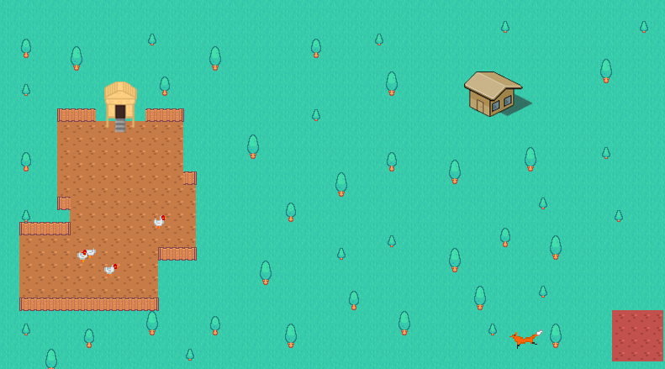

1. – Version History

|  |  |
| --- | --- |
| **Version** | **Description** |
| AI update | 30-07-2020 Ai initial push |
| AI update2 | 31-07-2020 Ai updated and edited push |
| AI commit | 12-08-2020 reinstating the AI document after it broke |
| AI commit 02 | 13-08-2020 more work going towards AI and pushed |
| AI commit 03 | 14-08-2020 another push updating work |
| AI commit 04 | 20-08-2020 another push updating work |
| AI final | 16-09-2020 final push to github with completed AI task |

1. – Development Environment

2.1 - Visual studio 2019

2.2 - Visual studio built in

2.3 - Uploading to github at the end of each day,

2.4 - <https://kenney.nl/assets> using a creative commons license

2.5 – Tiled

3.0 – I am aiming to create a chicken coop based ai script. The script will consist of chickens who wander in their coop, a farmer who feeds the chickens every morning and scares a fox away when it attacks, and a fox who hunts for the chickens in the evening.

4.0 - Entities

Chickens –

* Wander – around the chicken coop
* Flee – away from the fox
* Path find – To the trough

Fox –

* Chase – The chickens for food
* Path find – back to its “Bed?” after a chicken is eaten or if the chickens got away.

**5.0** – Item

Chicken Coop



Fox Area

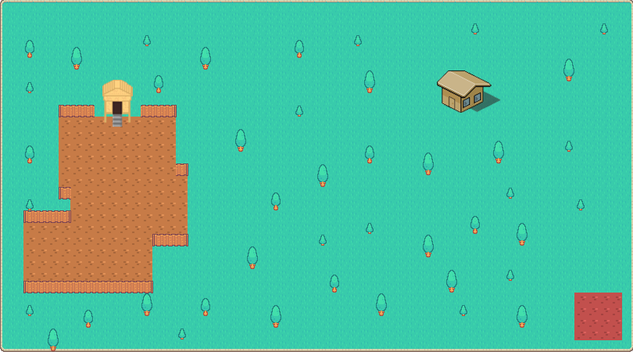

**6.0** – Levels

1 level where everything is set and where all the characters move and interact.



**7.0** – Asset List

|  |  |
| --- | --- |
| **Asset** | **Description** |
| Chicken | Chicken has several images that are used for the walking and eating animations as well as any flipped sprites |
| Fox | Like the chicken the fix uses different sprites for different animations as well as flipped sprites |
| Background | The background is one solid image that uses a graph over the top to interact with the characters pathfinding and AI code. |

Evaluation

Though the product varied from the original idea, the base of the original idea is still present. The loss of the Farmer did not affect the fox and chicken interactions. Pressing TAB enables debugging which includes the visualisations of pathfinding and radius scanning. Overall I am happy with the final product :)